ArcMap 10.4.1 installs python 2.7.10, which includes some 3rd party libraries (C:\Python27\ArcGIS10.4\Lib\site-packages). It doesn’t include “xlsxwriter” and the version of Pandas included is old: 0.16.1. To run NMDOT GIS Tools, xlsxwriter needs to be installed and Pandas needs to be updated to 0.23.0 using pip, which is Python’s official python package manager. It is a command line tool that allows you to install, update, and remove python packages. It is included in ArcMap 10.4.1, but you must either 1) navigate to pip.exe in the shell prior to using it OR 2) you can provide the path to pip and run it that way.

1. Open the shell and type cd../.. to get to the C root (when ArcMap is installed, by default, it places Python 2.7 at the root).

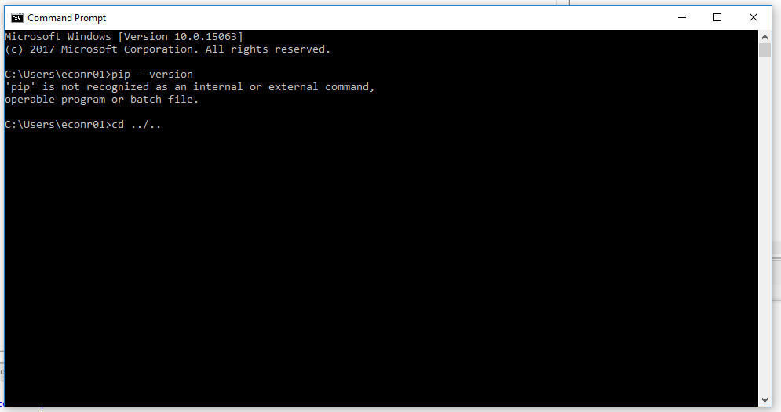

Once at the root drive, type dir to confirm that Python27 is there.

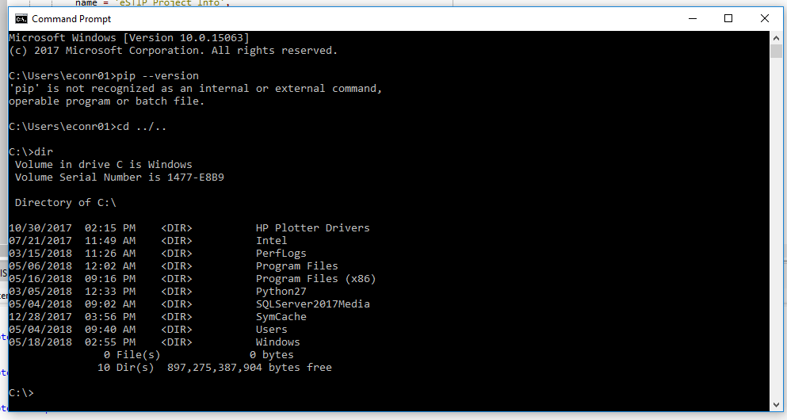

Go to the directory where pip resides: cd Python27\ArcMap10.4\Scripts

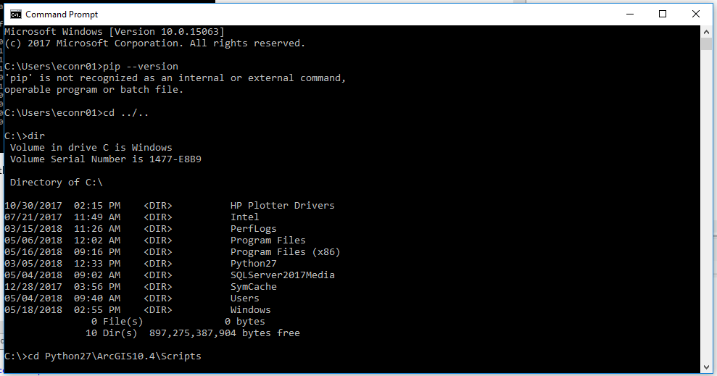

1. You can run pip without navigating directly to the folder by specifying the path prior to your pip commands. Example:

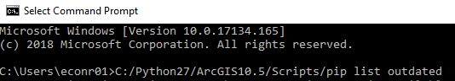

Now you’re ready to run pip. You can see that it resides in this folder by typing dir.

**Common Commands: (full documentation here:** [**https://pip.pypa.io/en/stable/**](https://pip.pypa.io/en/stable/)**)**

1. Check if there are any outdated python packages: pip list –outdated
2. Update a package: pip install --upgrade pandas
3. Install a new package: pip install xlsxwriter
4. Uninstall a package: pip uninstall pandas
5. View information about a particular package: pip show pandas
6. Install particular version of a a package: pip install pandas==0.23.0
7. Check that a package has all dependencies installed: pip check pandas

According to Pandas 0.23.0 release notes, new versions will soon stop supporting Python 2.7.

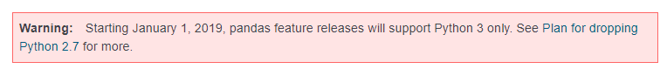

<https://pandas.pydata.org/pandas-docs/stable/whatsnew.html>